**Session 1**

1. Create a Thread by extending the Thread class.

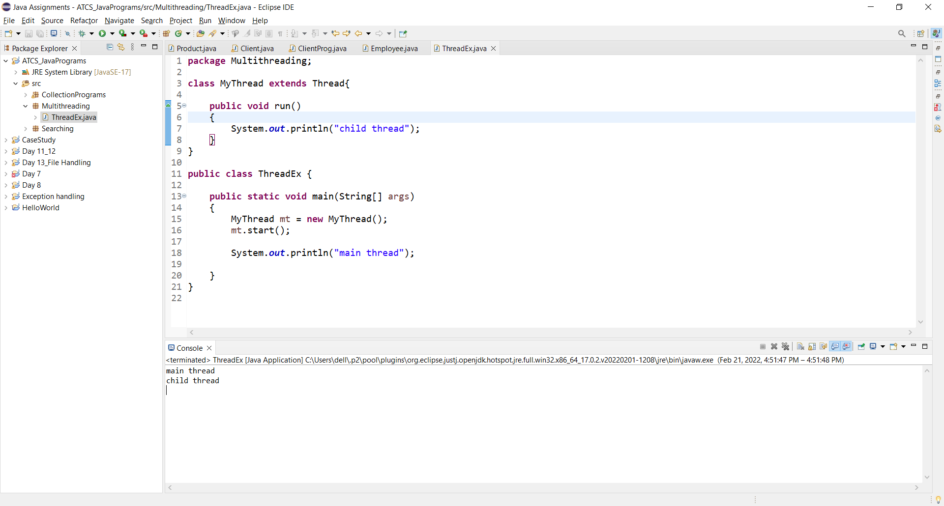

1. Create a Thread by Implements the Runnable Interface.

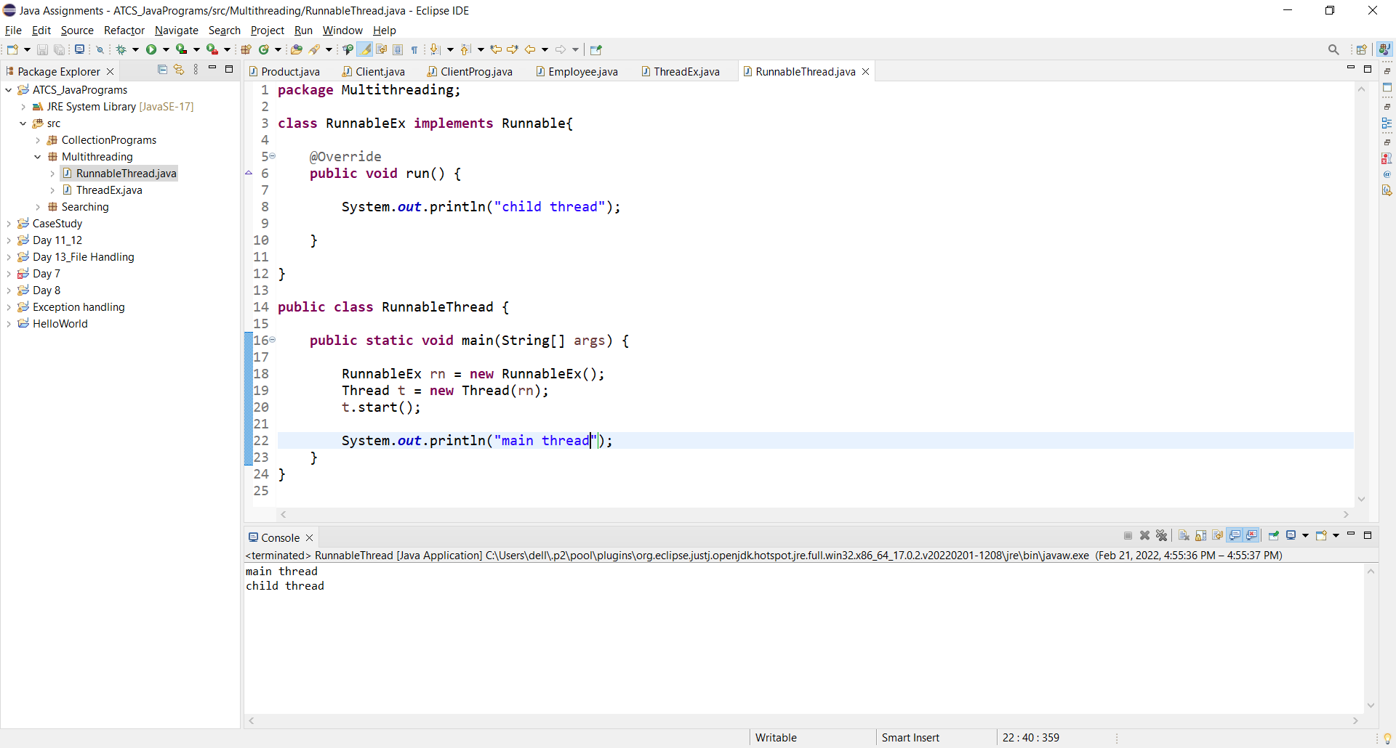

1. Create a Thread by extending Thread class set and get the name of thread.

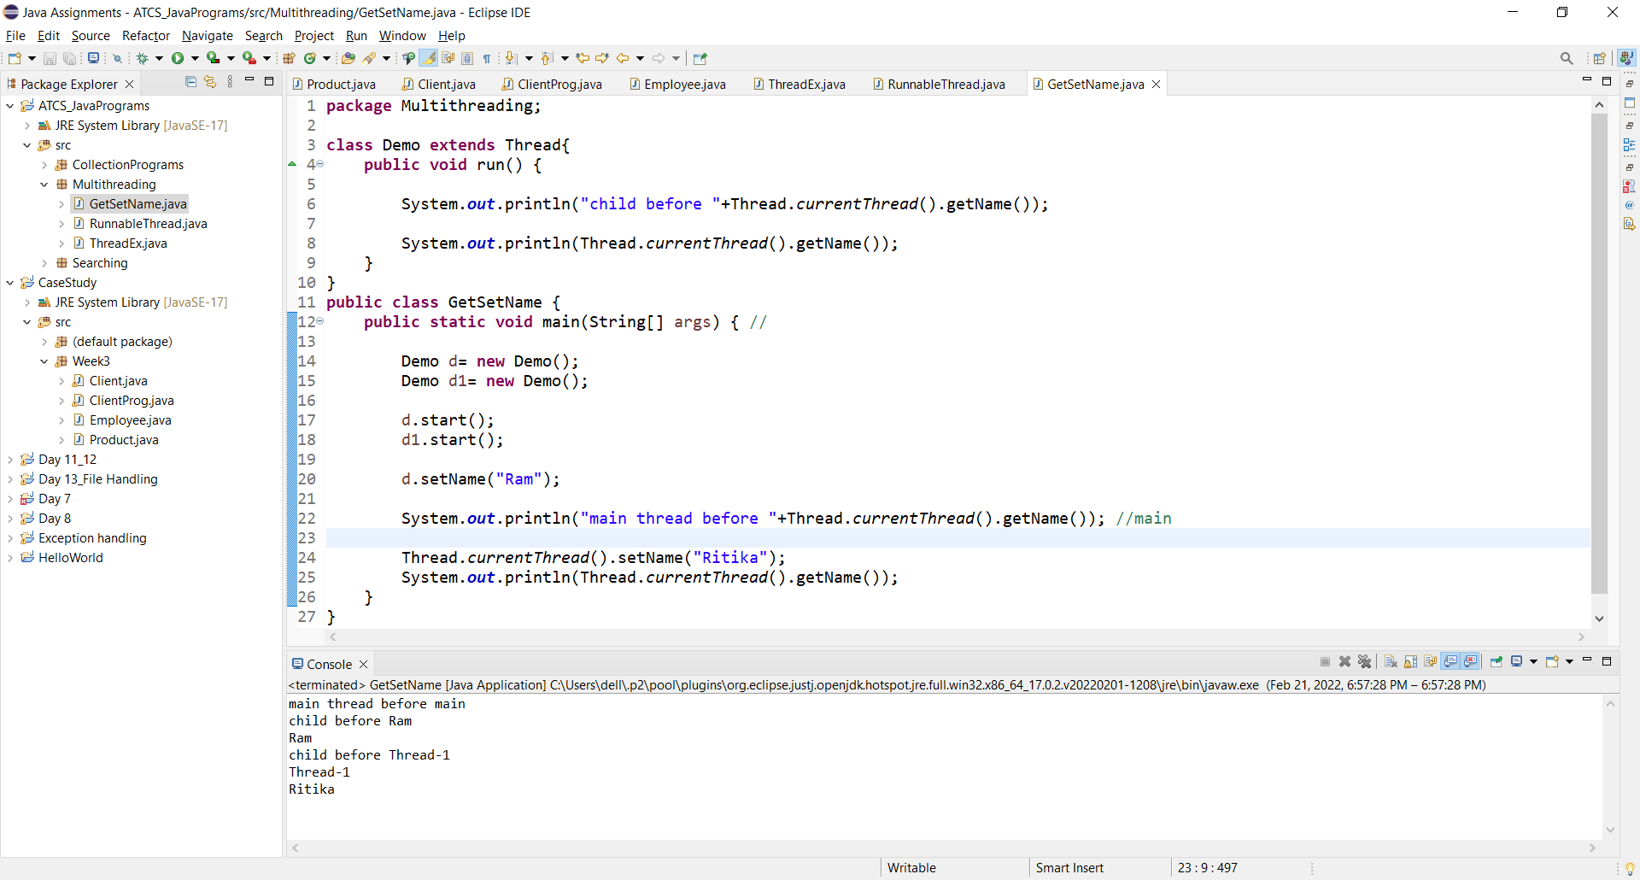

1. Create a Thread by extending Thread class set and get the priority of thread.

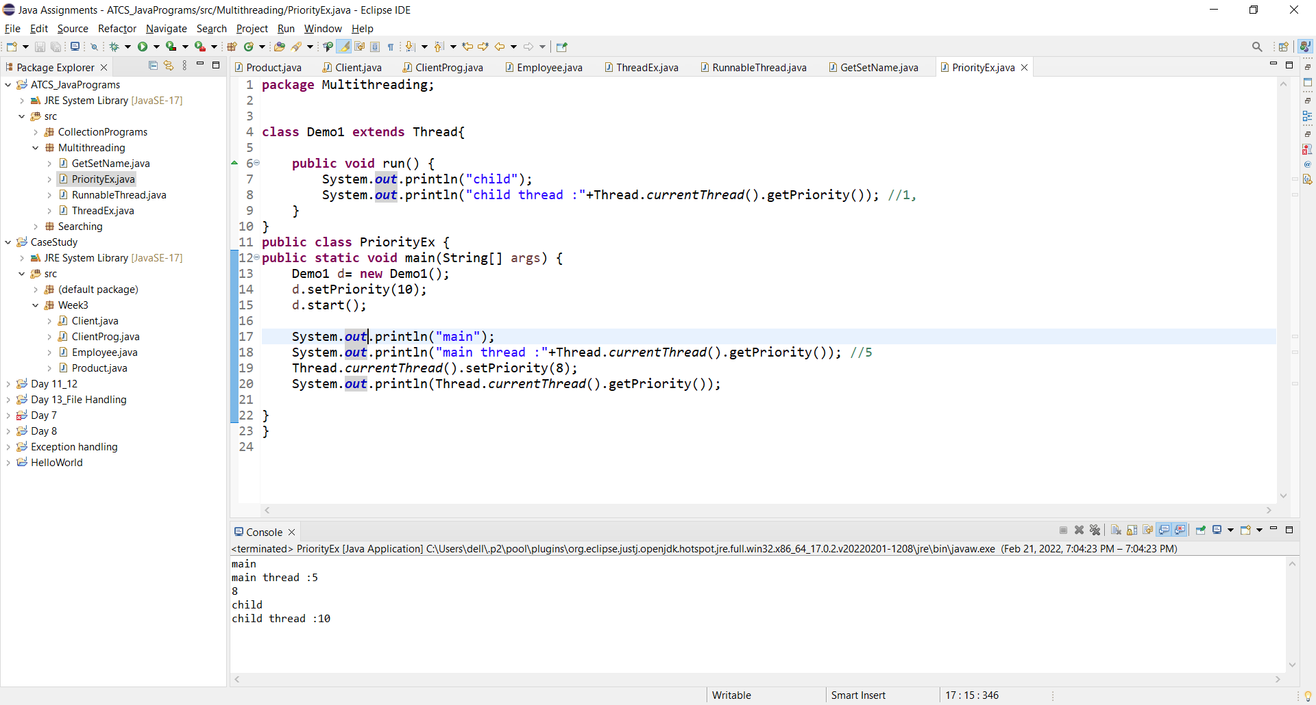

1. Create a Thread by extending Thread class apply Yield Method.

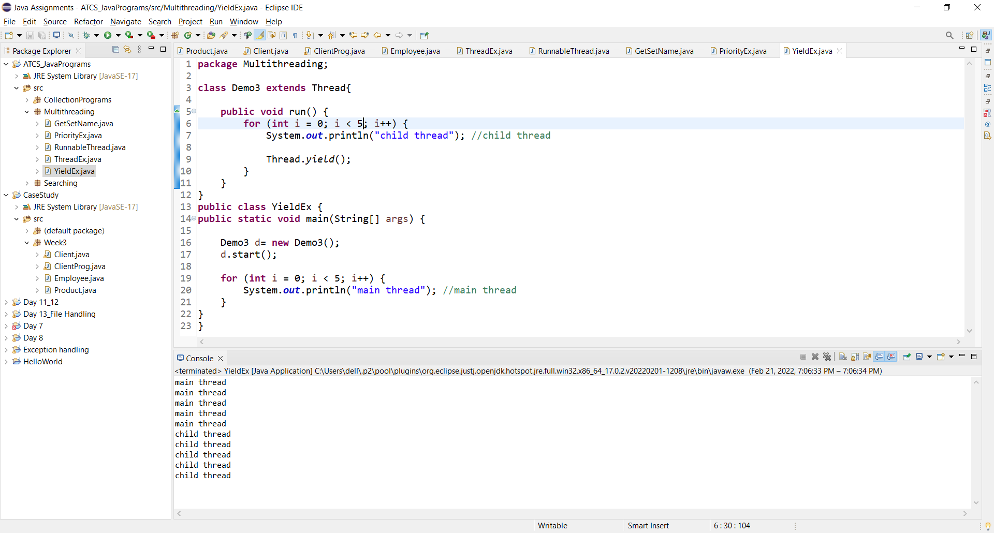

1. Create a Thread by extending Thread class apply join Method.

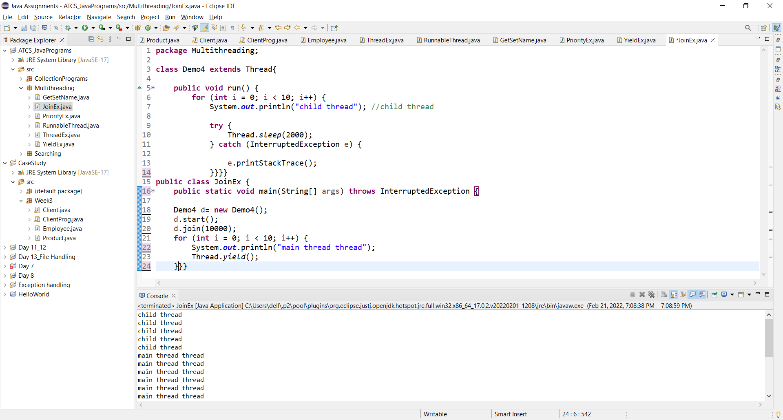

1. Create a Thread by extending Thread class apply sleep Method.

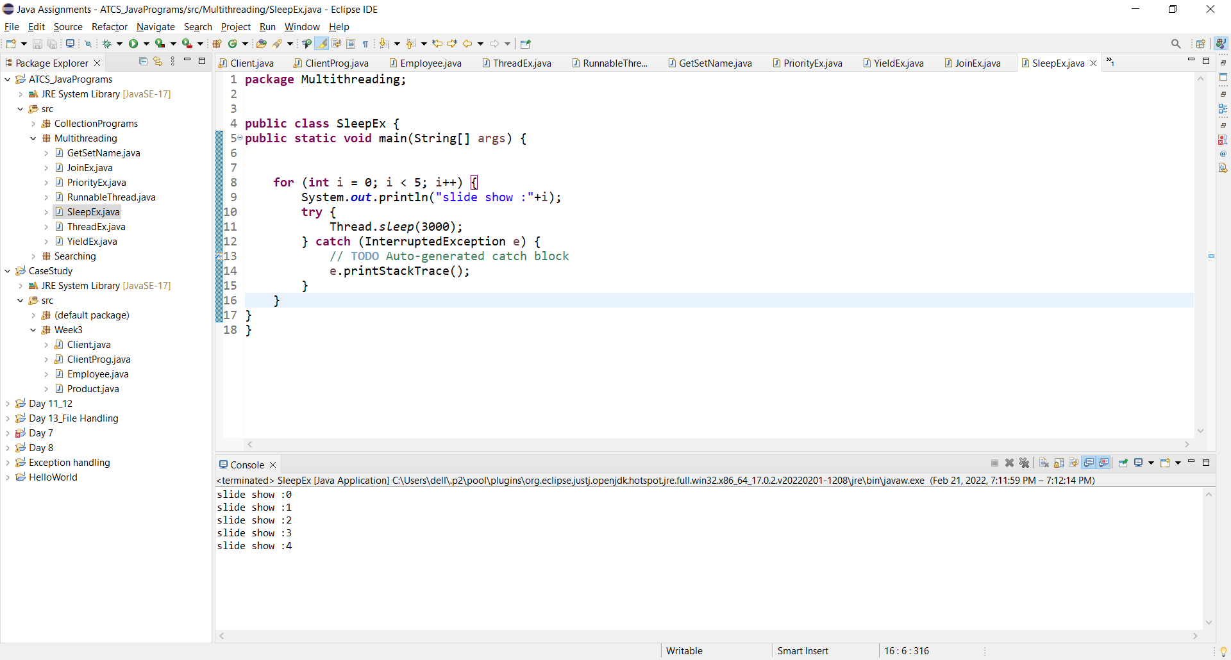

**Session 2**

1. Create a Deadlock class to demonstrate deadlock in multithreading environment.

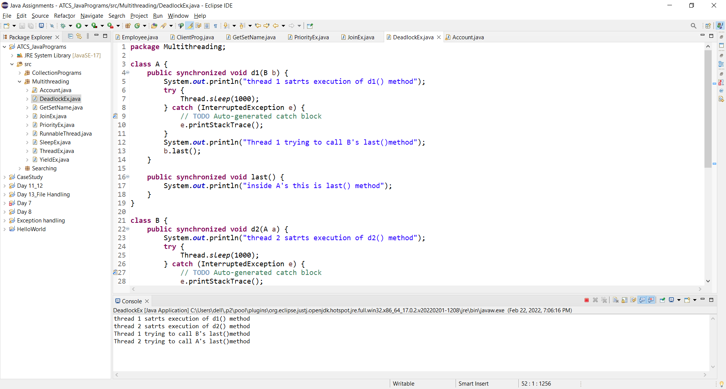

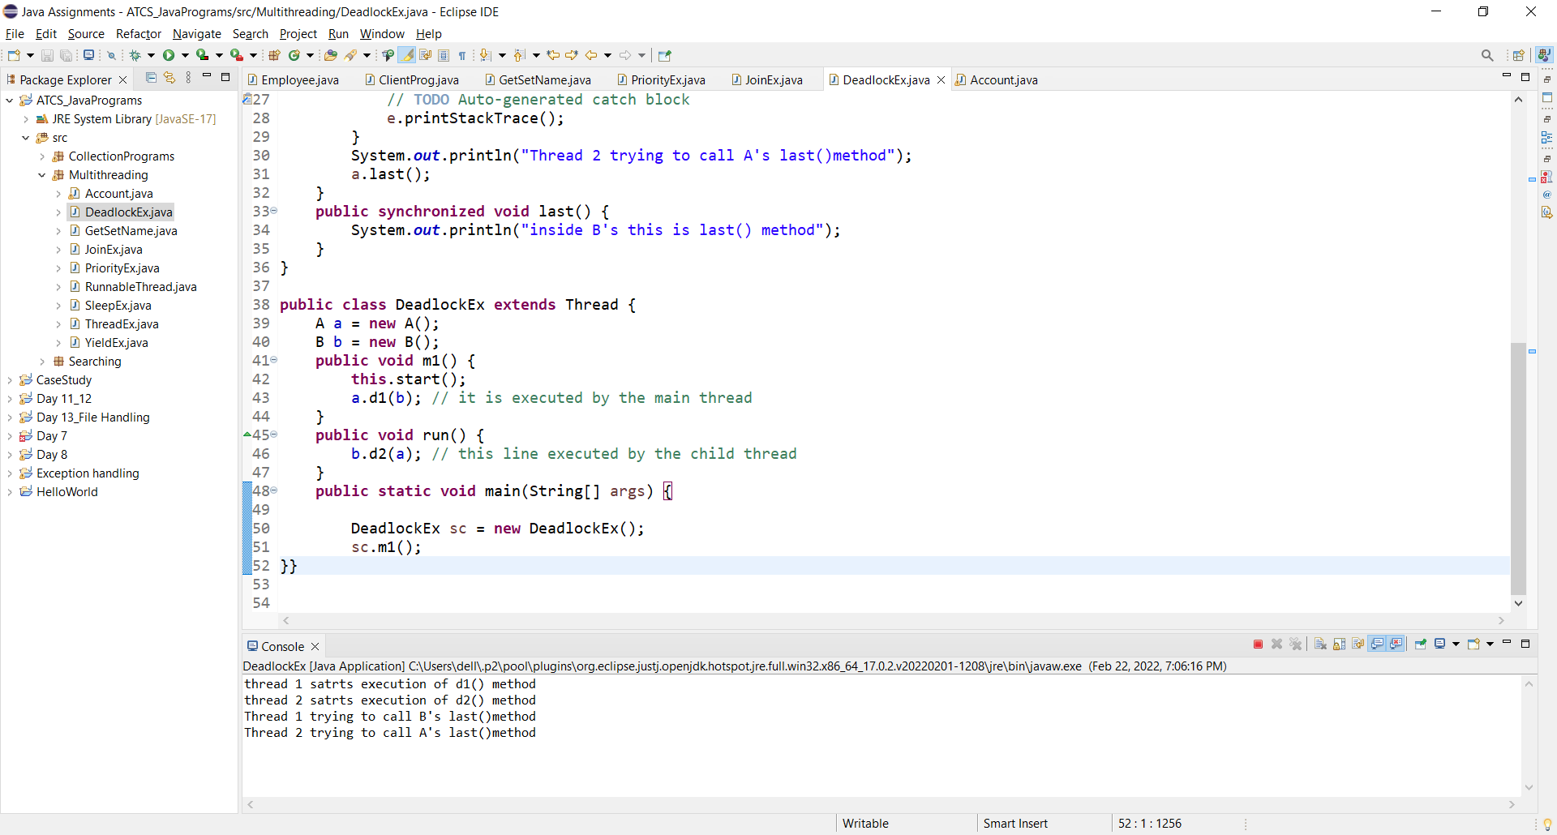

1. Implement wait, notify and notifyAll methods.

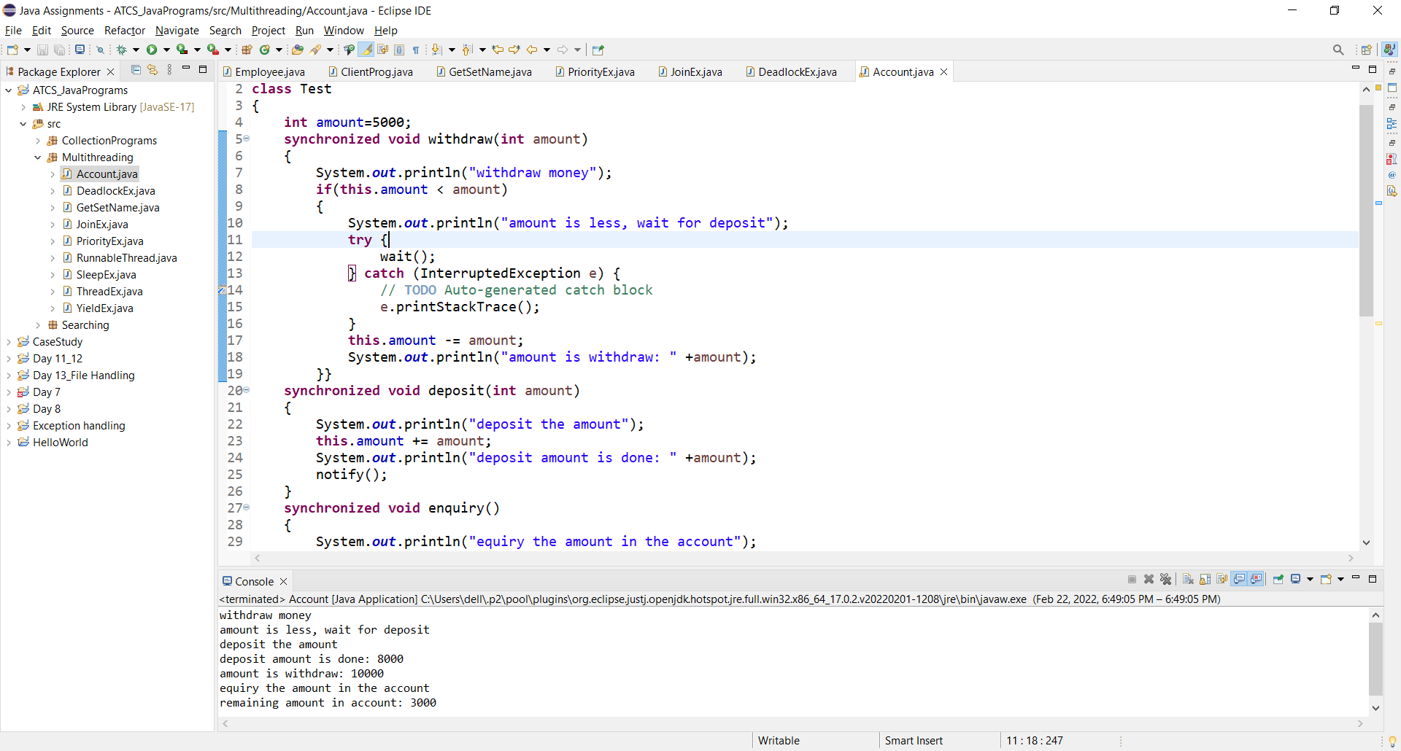

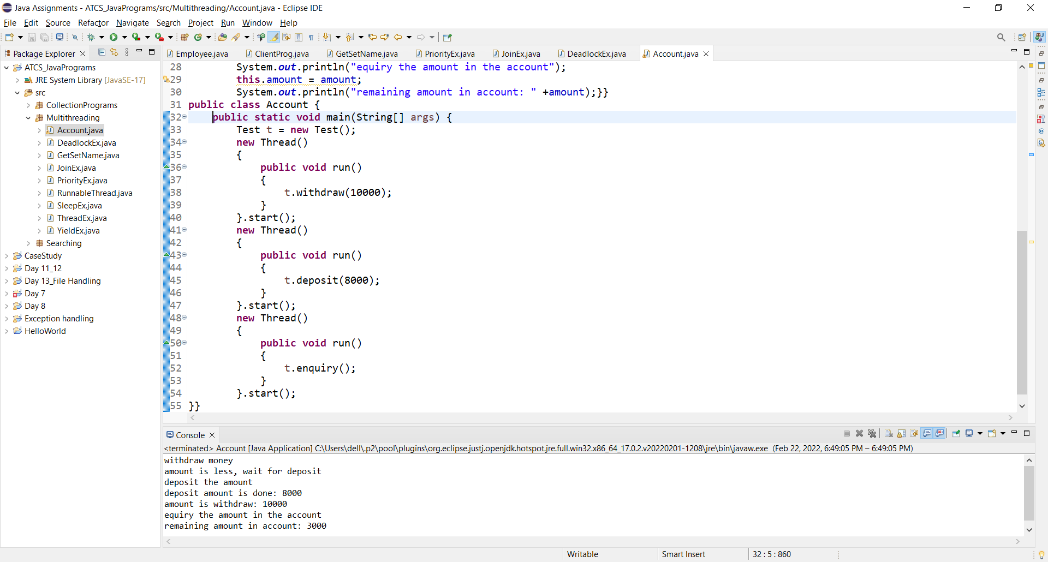

1. Create a Account class with methods withdraw, deposit, enquiry, add with synchronized keywords observe the output.



